User groups and permissions.
--> Create a group named "manager"
--> A user sarah and harry should belong to the "manager" group as a secondary group.
--> User Natasha should have a non-interactive shell and she should not be a member of the "manager" group.
--> Password for all users created should be "redhat123".
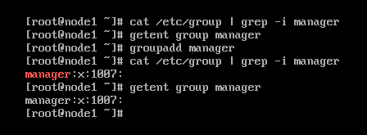
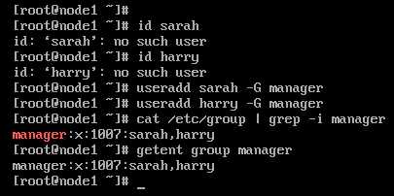
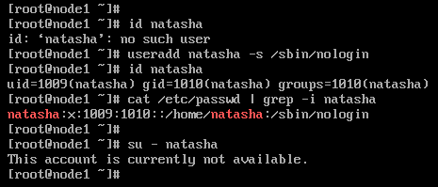

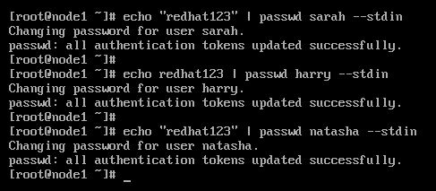

Create user with uid
Create the user "jean" with uid 4332 with password "redhat123".
